# Figures and Tables



Figure . Study Area

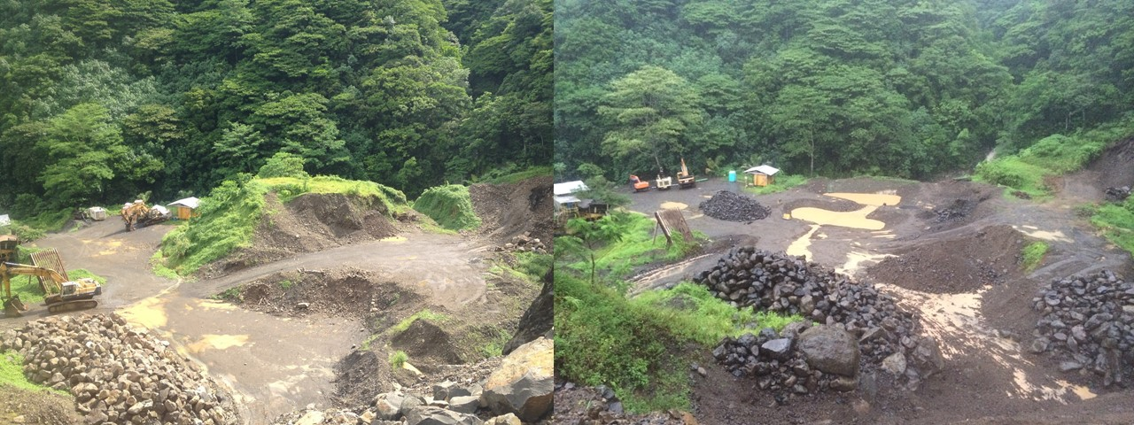

Figure . Retention ponds, upper platform, in LEFT: July 2013 and RIGHT: December 2014

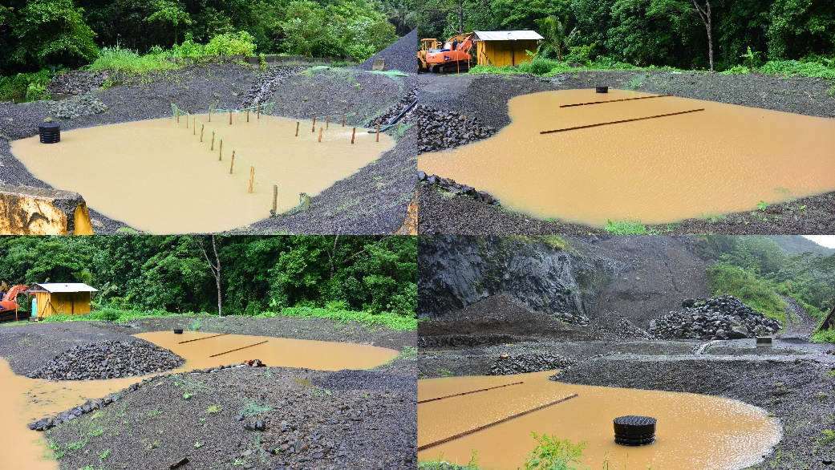

Figure . Retention ponds, close up

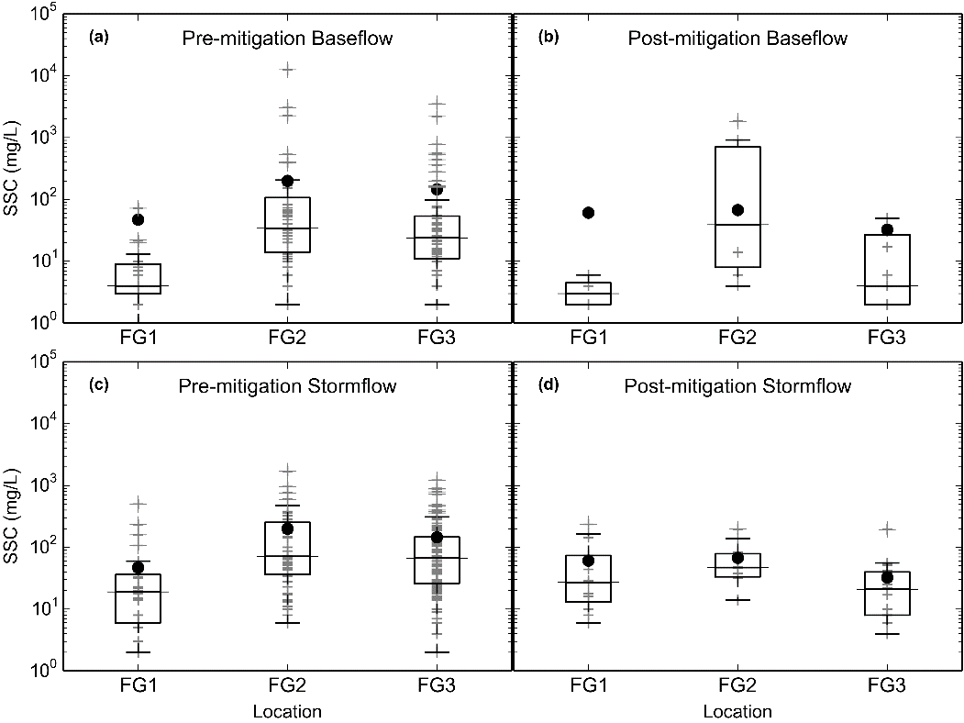

Figure . Boxplots of SSC grab samples (no Autosampler), during baseflow and stormflow, pre-and post-mitigation. Grey crosses are individual samples, black dots are mean values.. a) Baseflow pre-mitigation, b) Baseflow post-mitigation….

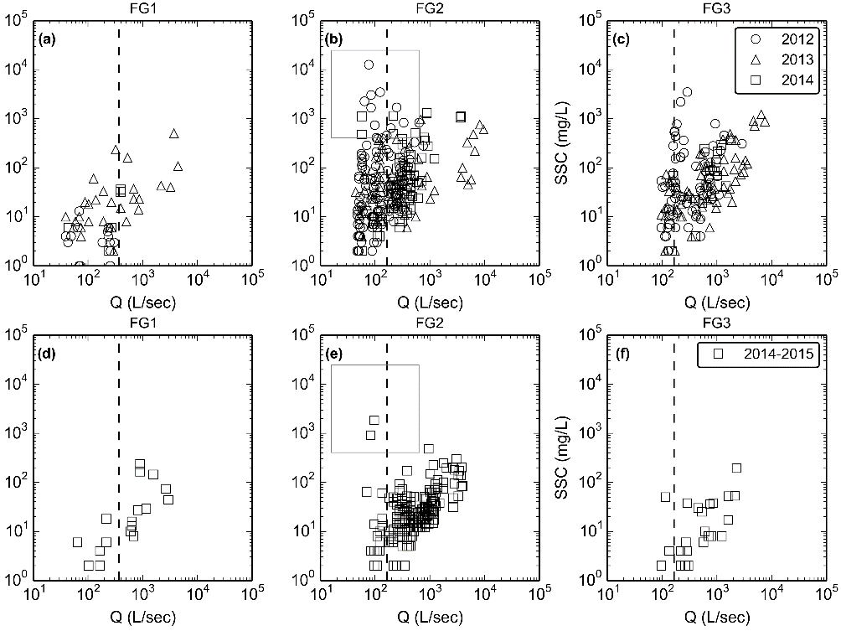

Figure . Water discharge vs. Sediment concentration (a-c) pre- and (d-f) post-mitigation

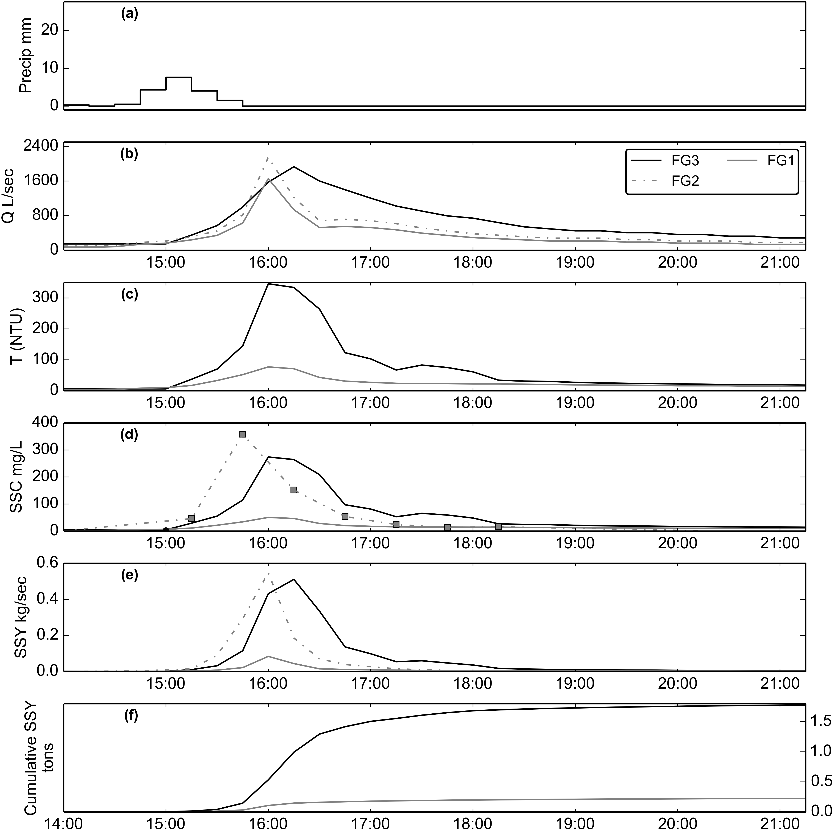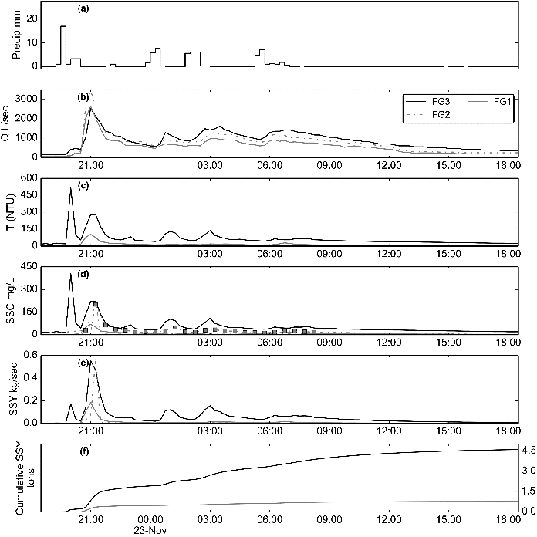

Figure . Example of storm event before sediment mitigation (02/14/2014) and after (11/22/2014) mitigation . SSY at FOREST and VILLAGE calculated from SSC modeled from T, and SSY at QUARRY from SSC samples collected by the Autosampler.

|  |  |  |  |  |  |  |  |  |  |  |
| --- | --- | --- | --- | --- | --- | --- | --- | --- | --- | --- |
| Table 2. Sediment discharge from subwatersheds in Faga'alu | | | | | | | | | | |
| Storm Start | Storm# | Precip (mm) | UPPER tons | UPPER PE % | LOWER tons | TOTAL tons | SSY data source | TOTAL PE % | % UPPER | % LOWER |
| 10/15/2014 | 1 | 17 | 0.11 | 36 | 0.5 | 0.62 | T | 52 | 18.0 | 81.0 |
| 10/15/2014 | 2 | 17 | 0.19 | 36 | 0.33 | 0.52 | T | 52 | 36.0 | 63.0 |
| 11/02/2014 | 3 | 16 | 0.13 | 36 | 0.92 | 1.05 | T | 52 | 12.0 | 87.0 |
| 11/12/2014 | 4 | 1 | 0.01 | 36 | 0.24 | 0.25 | T | 52 | 3.0 | 96.0 |
| 11/12/2014 | 5 | 13 | 0.3 | 36 | 0.02 | 0.32 | T | 52 | 94.0 | 5.0 |
| 11/22/2014 | 6 | 78 | 0.77 | 36 | 3.79 | 4.56 | T | 52 | 16.0 | 83.0 |
| 11/24/2014 | 7 | 20 | 0.05 | 36 | 0.52 | 0.57 | T | 52 | 9.0 | 90.0 |
| 12/04/2014 | 8 | 65 | 0.26 | 36 | 1.45 | 1.71 | T | 52 | 15.0 | 84.0 |
| 12/09/2014 | 9 | 34 | 3.1 | 36 | 12.35 | 15.45 | T | 52 | 20.0 | 79.0 |
| 12/19/2014 | 10 | 62 | 1.1 | 36 | 2.16 | 3.26 | T | 52 | 33.0 | 66.0 |
| 12/21/2014 | 11 | 143 | 2.52 | 36 | 5.5 | 8.02 | T | 52 | 31.0 | 68.0 |
| Total/Avg: | 11 | 466 | 8.5 | 36 | 27.8 | 36.3 |  | 52 | 24 | 76 |
| Tons/km2 |  |  | 9.5 |  | 31.6 | 20.4 |  |  | - | - |
| DR |  |  | 1 |  | 3.3 | 2.2 |  |  | - | - |
| fraction disturbed (%) |  |  | 0.4 |  | 10.1 | 5.2 |  |  | - | - |
| SSY from forested areas (tons) |  |  | 8.5 |  | 7.5 | 16.0 |  |  | - | - |
| SSY from disturbed areas (tons) |  |  | 0.0 |  | 20.3 | 20.3 |  |  | - | - |
| % SSY from disturbed areas |  |  | 0.4 |  | 73 | 56 |  |  | - | - |
| sSSY from disturbed areas (tons/km2) |  |  | 9.5 |  | 228.1 | 219.5 |  |  | - | - |
| DR for sSSY from disturbed areas |  |  | - |  | 24 | 23 |  |  | - | - |

|  |  |  |  |  |  |  |  |  |  |
| --- | --- | --- | --- | --- | --- | --- | --- | --- | --- |
| Table 3. Sediment discharge from subwatersheds in Faga'alu | | | | | | | | | |
| Storm Start | Storm# | Precip (mm) | UPPER tons | LOWER_QUARRY tons | LOWER_VILLAGE tons | TOTAL tons | % UPPER | % LOWER_QUARRY | % LOWER_VILLAGE |
| 11/02/2014 | 1 | 16 | 0.13 | -0.05 | 0.97 | 1.05 | 12.0 | -4.0 | 92.0 |
| 11/12/2014 | 2 | 1 | 0.01 | -0.01 | 0.25 | 0.25 | 4.0 | -4.0 | 100.0 |
| 11/12/2014 | 3 | 13 | 0.3 | -0.3 | 0.32 | 0.32 | 93.0 | -93.0 | 100.0 |
| 11/16/2014 | 4 | 27 | 1.54 | -1.52 | 0.73 | 0.75 | 205.0 | -202.0 | 97.0 |
| 11/18/2014 | 5 | 5 | 0.79 | -0.79 | 0.17 | 0.17 | 464.0 | -464.0 | 100.0 |
| 11/19/2014 | 6 | 3 | 0.22 | -0.22 | 0.12 | 0.12 | 183.0 | -183.0 | 100.0 |
| 11/22/2014 | 7 | 78 | 0.77 | 0.03 | 3.76 | 4.56 | 16.0 | 0.0 | 82.0 |
| 11/24/2014 | 8 | 20 | 0.05 | 0.03 | 0.49 | 0.57 | 8.0 | 5.0 | 85.0 |
| 12/04/2014 | 9 | 65 | 0.26 | -0.2 | 1.65 | 1.71 | 15.0 | -11.0 | 96.0 |
| 12/09/2014 | 10 | 34 | 3.1 | -2.26 | 14.61 | 15.45 | 20.0 | -14.0 | 94.0 |
| 12/19/2014 | 11 | 62 | 1.1 | -0.8 | 2.96 | 3.26 | 33.0 | -24.0 | 90.0 |
| 12/21/2014 | 12 | 143 | 2.52 | -0.31 | 5.81 | 8.02 | 31.0 | -3.0 | 72.0 |
| Total/Avg: | 12 | 467 | 11 | -6 | 32 | 36 | 30 | -18 | 88 |
| Tons/km2 |  |  | 12 | -24 | 52 | 20 | - | - | - |
| DR |  |  | 1.0 | -1.98 | 4.4 | 1.7 | - | - | - |
| fraction disturbed (%) |  |  | 0.4 | 6.5 | 11.7 | 5.2 | - | - | - |
| SSY from forested areas (tons) |  |  | 10.7 | 3.0 | 6.5 | 20.2 | - | - | - |
| SSY from disturbed areas (tons) |  |  | 0.0 | -9.43 | 25.4 | 16.0 | - | - | - |
| % SSY from disturbed areas |  |  | 0.4 | 147 | 80 | 44 | - | - | - |
| sSSY from disturbed areas (tons/km2) |  |  | 12.0 | -537.1 | 355.6 | 172.9 | - | - | - |
| DR for sSSY from disturbed areas |  |  |  | -44.8 | 29.7 | 14.4 | - | - | - |

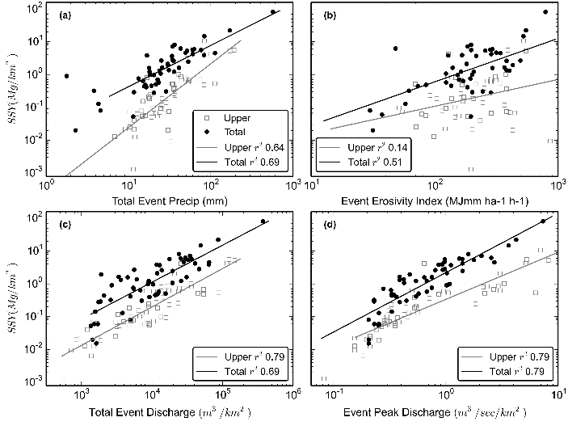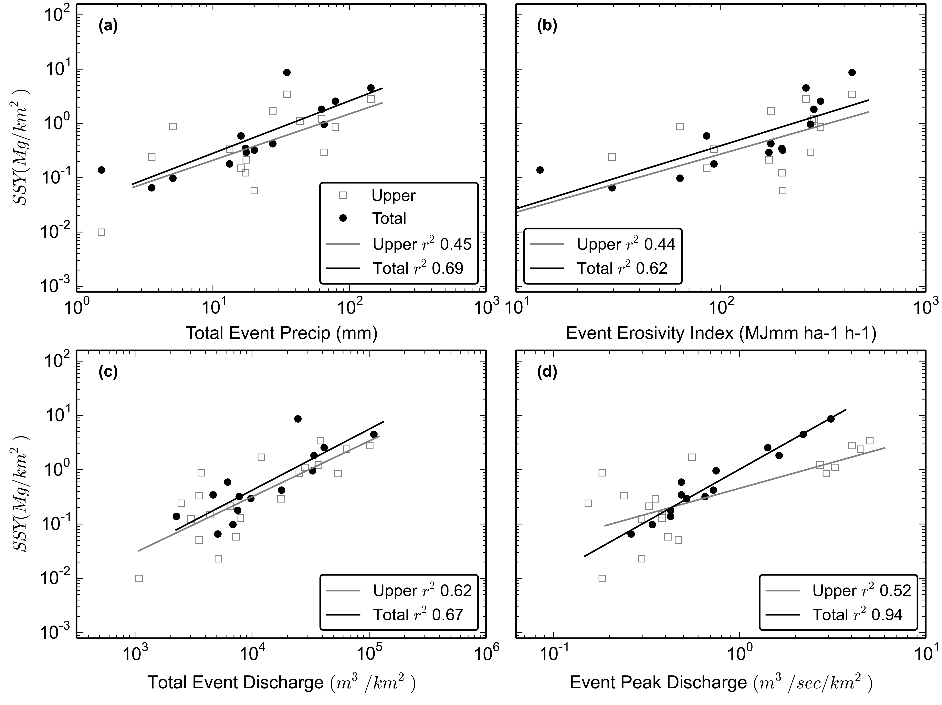

Figure . Storm metrics pre and post-mitigation

|  |  |  |  |  |  |  |
| --- | --- | --- | --- | --- | --- | --- |
| Table 4. Model statistics | | | | | | |
| Model | Pearson | Spearman | r2 | RMSE(tons) | alpha | Beta |
| Psum_upper | - | - | 0.45 | 3.35 | 0.027 | 0.85 |
| Psum_total | 0.83 | 0.88 | 0.69 | 2.33 | 0.054 | 0.97 |
| EI_upper | - | - | 0.44 | 3.38 | 0.002 | 1.07 |
| EI_total | 0.78 | 0.88 | 0.62 | 2.57 | 0.003 | 1.16 |
| Qsum_upper | 0.79 | 0.74 | 0.62 | 2.81 | 0.000 | 1.03 |
| Qsum_total | 0.82 | - | 0.67 | 2.39 | 0.000 | 1.12 |
| Qmax_upper | 0.72 | - | 0.52 | 3.21 | 0.454 | 0.95 |
| Qmax_total | 0.97 | 0.94 | 0.94 | 1.45 | 0.598 | 1.92 |